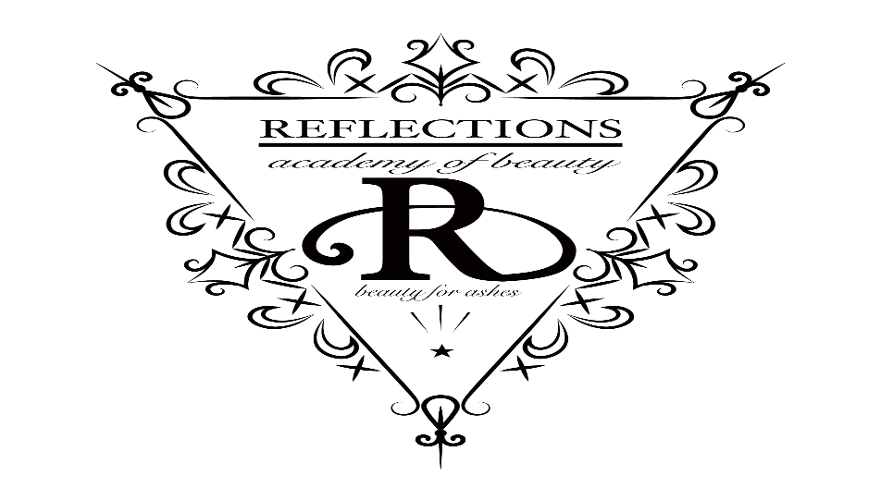

Reflections Academy of Beauty is dedicated to positive student success by grooming able bodied, professional, self-confident and career oriented graduates prepared with the knowledge and a hands on skill set to meet the prerequisites of business and customer service of the beauty industry.
We will strive daily to accommodate the needs of our student salon clients. Bringing high quality and multi-cultural talent to your service needs, making our clientele feel beautiful from the inside out.
All services are performed by salon students supervised by licensed educators.

241 North Main Street Decatur Illinois 62523
p.217.425.9117 f.217.425.9203 shearlearning.com

